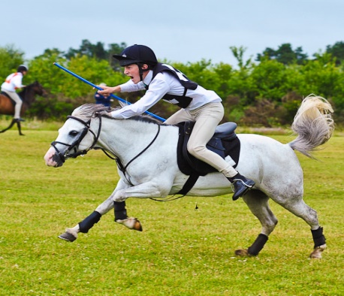
Mounted EQUESTRIAN Games
Come learn and explore the FUN!!!
When: May 7, 2017 10 AM – 2 PM
Who: Anyone Interested in Mounted Games (all ages, including adults)
Where: Fox Valley Saddle Association
44W300 Rohrsen Road, Hampshire, Illinois 60140
Clinic format in the AM to learn and practice games
Lunch Break (cash and carry LUNCH/ SNACKS available)
Games “Friendly” Competition in PM after Lunch
Cost $35 per rider $45 @ the Door
Stalls Available and recommended for lunch time $20 per stall must be requested prior to event
Coaching! Music! Fun! Friends! Don’t miss out on this fun equestrian sport!
RSVP by 5/1 Questions: Heather Fortcamp kfortcam@comcast.net or call /text 847 650 1464
Coggins, Waiver, and Entry needed to participate please save your space today!!

