Area IV YR Program is excited to promote a Clinic with Emily Beshear, our Area IV YR Coach,
on October 10-11th, 2015

The two day clinic will be hosted at Cresswood Farm in Barrington, IL
and The FRVPCHT course, weather permitting

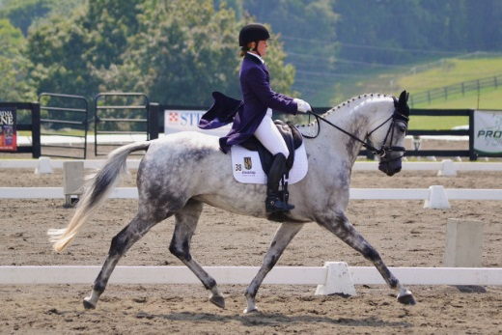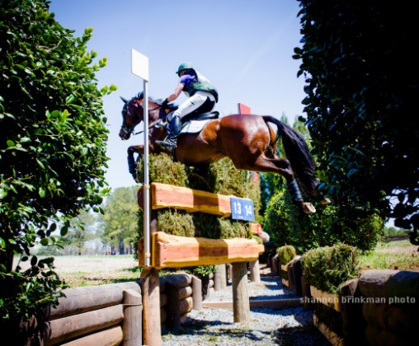

Clinician – Emily Beshear

Area IV Welcomes Emily Beshear, our 2015 Young Rider Coach to Illinois, fresh from her incredible 7th place finish at the Blenheim 3 Star Competition in Europe!
Emily, a 4* rider and a Level 4 ICP Certified Instructor, grew up in Michigan and is currently based in Somerset, VA. Emily’s inexhaustible energy and unwavering passion to her profession have enhanced her natural talent. Personally, she has been victorious in numerous National and International competitions while also showing an exceptional ability to produce horses to the highest levels of the sport for other top riders. The US Team has taken notice by naming Emily to the USEF Developing Rider Training List on six separate horses. http://www.emilybeshear.com/

Spend two days with other Area IV Young and Adult Riders working with Emily to finesse your dressage and focus on your jumping techniques. It’s a great way to end the season and get some ideas for your winter training plans!!!

Don’t miss out ~ Space is very limited !!!
Entry deadline is October 4, 2015
First priority will be given to Young Riders.

YR Clinic Entry Oct 10th & 11th, 2015

Rider Name ___________________________________________
USEA # _______ USEF #________ FEI #____________________
Address ______________________________________________
City ____________________________ State _____ Zip ________
Day phone _____________________ Cell phone ______________
Email _________________________________________________
Where staying while attending clinic? _______________________
If you are leaving a trailer, size of trailer?_____________________

Highest Level Rider has completed __________________________

******************************************************************************
Horse Competition Name __________________________________
Horse USEA # ____________ USEF #__________ FEI#_________
Highest-level horse has completed ___________________________
Currently Competing ______________________________________
*******************************************************************************
What are your goals for the clinic? _________________________________
___________________________________________________________

Mail Entry, Releases and Coggins to: (Checks are payable to USEA Area IV)

Area IV YR Clinic
c/o Tudor Oaks Farm
401 W. Cuba Rd
Barrington Hills, Illinois 60010

Check List for Complete Application:
o Check to USEA Area IV for $300* for clinic
o Additional Stabling $30/day - does not include shavings
o Signed release forms (USEA, Cresswood Farm)
o Current Coggins
o YR Clinic Entry form

For questions, please contact Chris Skudlarek @ 224-717-4011 or cskudlarek66@gmail.com.
Release Form
For USEA Educational Activities & Schooling Shows

Name of Activity/Schooling Show: __Area IV YR Clinic___________________USEA Area:__IV_____________
Date(s)to be held:_Oct 10 & 11, 2015______ Location: Cresswood Farm_________State:__Illinois___________
I have applied to participate in this USEA sponsored educational activity. I agree that my participation is subject to the
Conditions in this release and to those set by the organizer of this activity, the regulations and requirements of the USEA, and, where applicable, the U.S. Equestrian Federation Rules for Eventing.
I agree to wear protective headgear when riding. When jumping, I agree to wear protective headgear passing or
Surpassing the ASTM/SEI standards with harness attached that meets standards currently imposed by the U.S. Equestrian Rules for Eventing. I understand that the USEA mandates that all riders participating in cross-country activity wear body-protecting vests that meet or exceed current USEF rules and the wearing of an approved medical armband.
I understand that the sport of eventing is a high risk sport, and that my participation in this educational activity may also involve participation in an "equine activity" as defined by applicable laws and is solely at my own risk. I understand that my participation involves all inherent risks associated with the dangers and conditions which are an integral part of equine activities, including, but not limited to, the propensity of equines to behave in ways which may result in injury, harm or even death to humans or other animals around or near them; the unpredictability of equine reaction to sounds, sudden movements, smells, and unfamiliar objects; persons or other animals; hazards related to surface and subsurface conditions; collisions with other equines or objects; and, the potential of a participant to act in a negligent or unskilled manner which may contribute to injury to the participant or others, including failing or inability to maintain control over the animal. By participating in this activity I agree to assume responsibility for those risks, and I release and agree to hold harmless the activity organizer, organizing committee, officials, the USEA, USEF, their officers, agents, employees and the volunteers assisting in the conduct of this USEA educational activity and the owners of any property on which it is to be held, from all liability for negligence resulting in accidents, damage, injury or illness to myself and to my property, including the horse(s) which I may ride.
I understand and agree that the organizer of this USEA educational activity has the right to cancel this activity; to refuse any entry or application; to require and enforce the wearing of safety or other attire and the conduct of riders, horses, and visitors; and to prohibit, stop or control any action during the activity deemed by the organizer to be improper or unsafe.
THIS FORM MUST BE FILLED OUT COMPLETELY AND SIGNED IF YOU WISH TO PARTICIPATE IN THIS ACTIVITY.
Participant’s Name (Please Print):_________________________________________________________________________________________
Address:______________________________________________________________________________________________________________
City:_________________________________________________State:__________________________________ ZIP:______________________
Phone: ____________________Cell Phone: __________________Emergency Contact phone: ________________________________________
Fax: ____________________________________Email:________________________________________________________________________
Trainers Name (At this Event): ________________________________________________Phone:______________________________________
Number of horses I will be riding during activity (if applicable):________________
Level now riding (Check one if applicable):
□ Beginner Novice □ Novice □ Training □ Preliminary □ Intermediate □ Advanced
Check appropriate box:
□ I am a USEA member and my number is #:____________________________
□ I am not a USEA member
□ I am not a USEA member. I wish to join and enclose my membership form and dues.
□ Check here if participant is under 18 years old.
SIGNATURE: ____________________________________________Date:______________________________
(If Participant is under 18, Release must be signed by Parent or legal guardian, not by trainer or instructor.)

